UNITED STATES
SECURITIES AND EXCHANGE COMMISSION
Washington, D.C. 20549

SCHEDULE 14A

Proxy Statement Pursuant to Section 14(a) of
the Securities Exchange Act of 1934 (Amendment No. )

Filed by the Registrant ☒

Filed by a Party other than the Registrant ☐

Check the appropriate box:

☐ | Preliminary Proxy Statement

☐ | Confidential, for Use of the Commission Only (as permitted by Rule 14a-6(e)(2))

☐ | Definitive Proxy Statement

☒ | Definitive Additional Materials

☐ | Soliciting Material under §240.14a-12

H&R BLOCK INC
(Name of Registrant as Specified In Its Charter)

(Name of Person(s) Filing Proxy Statement, if other than the Registrant)

Payment of Filing Fee (Check the appropriate box):

☒ | No fee required.

☐ | Fee paid previously with preliminary materials.

☐ | Fee computed on table in exhibit required by Item 25(b) per Exchange Act Rules 14a6(i)(1) and 0-11

 | 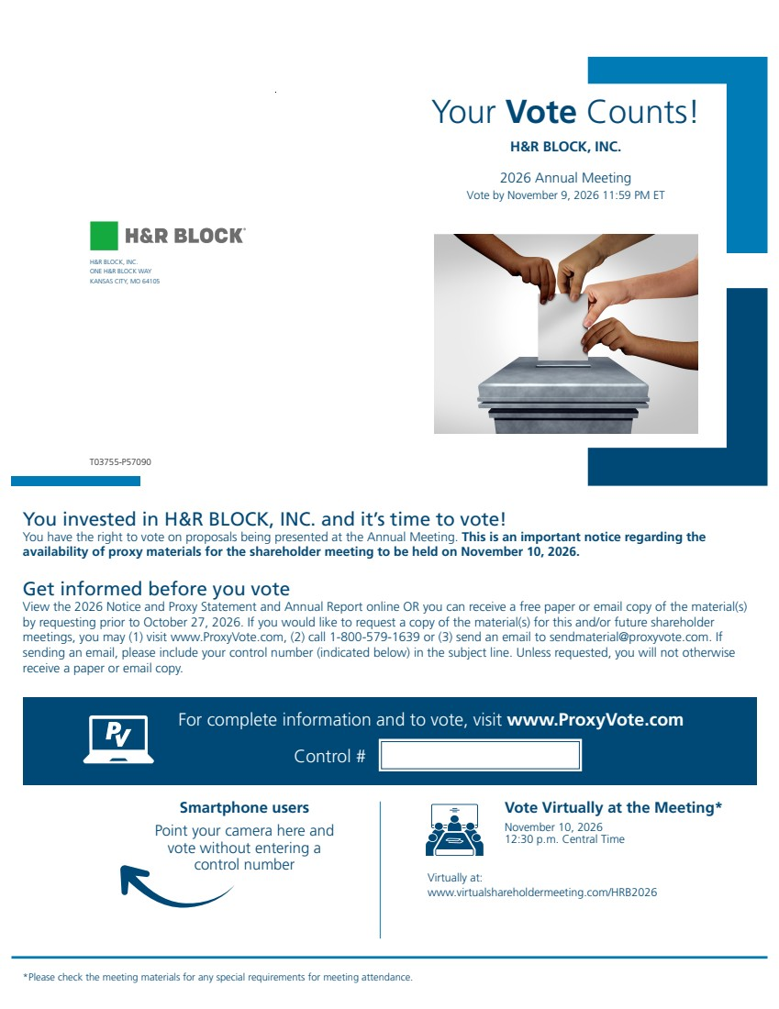 | Your Vote Counts! H&R BLOCK, INC. 2026 Annual Meeting Vote by November 9, 2026 11:59 PM ET You invested in H&R BLOCK, INC. and it’s time to vote! You have the right to vote on proposals being presented at the Annual Meeting. This is an important notice regarding the availability of proxy materials for the shareholder meeting to be held on November 10, 2026. Vote Virtually at the Meeting* November 10, 2026 12:30 p.m. Central Time Virtually at: www.virtualshareholdermeeting.com/HRB2026 *Please check the meeting materials for any special requirements for meeting attendance. Smartphone users Point your camera here and vote without entering a control number For complete information and to vote, visit www.ProxyVote.com Control # T03755-P57090 Get informed before you vote View the 2026 Notice and Proxy Statement and Annual Report online OR you can receive a free paper or email copy of the material(s) by requesting prior to October 27, 2026. If you would like to request a copy of the material(s) for this and/or future shareholder meetings, you may (1) visit www.ProxyVote.com, (2) call 1-800-579-1639 or (3) send an email to sendmaterial@proxyvote.com. If sending an email, please include your control number (indicated below) in the subject line. Unless requested, you will not otherwise receive a paper or email copy. H&R BLOCK, INC. ONE H&R BLOCK WAY KANSAS CITY, MO 64105
 | 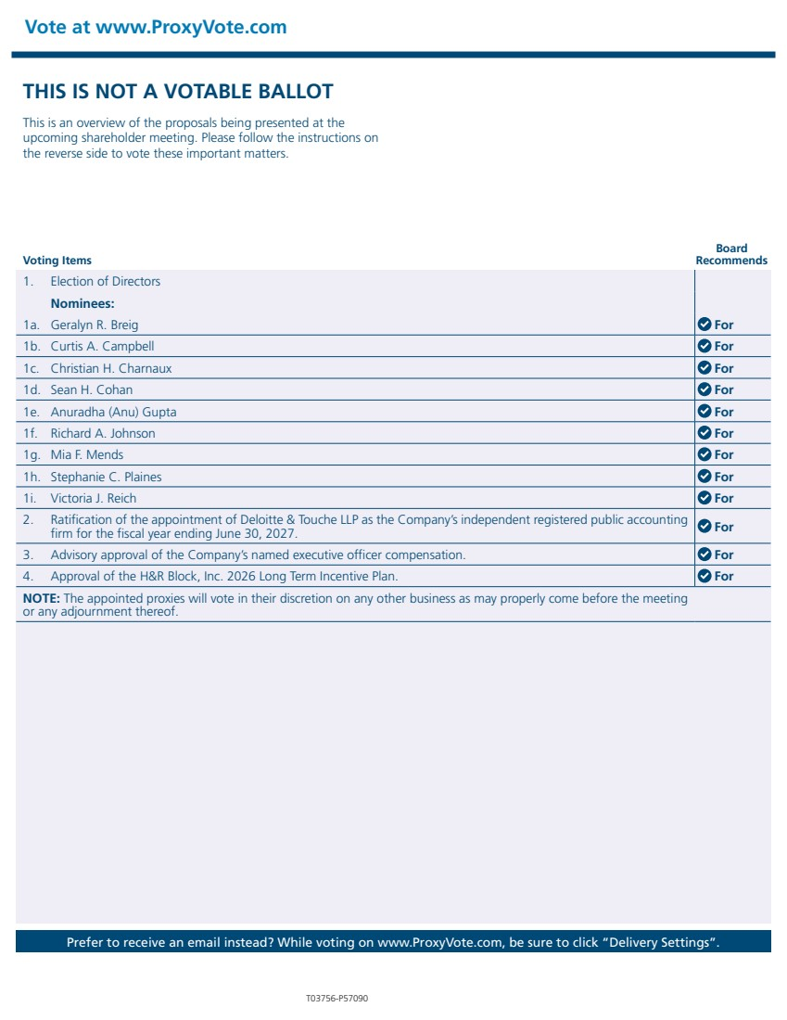 | THIS IS NOT A VOTABLE BALLOT This is an overview of the proposals being presented at the upcoming shareholder meeting. Please follow the instructions on the reverse side to vote these important matters. Vote at www.ProxyVote.com Prefer to receive an email instead? While voting on www.ProxyVote.com, be sure to click “Delivery Settings”. Voting Items Board Recommends T03756-P57090 1. Election of Directors Nominees: 1a. Geralyn R. Breig For 1b. Curtis A. Campbell For 1c. Christian H. Charnaux For 1d. Sean H. Cohan For 1e. Anuradha (Anu) Gupta For 1f. Richard A. Johnson For 1g. Mia F. Mends For 1h. Stephanie C. Plaines For 1i. Victoria J. Reich For 2. Ratification of the appointment of Deloitte & Touche LLP as the Company’s independent registered public accounting firm for the fiscal year ending June 30, 2027. For 3. Advisory approval of the Company’s named executive officer compensation. For 4. Approval of the H&R Block, Inc. 2026 Long Term Incentive Plan. For NOTE: The appointed proxies will vote in their discretion on any other business as may properly come before the meeting or any adjournment thereof.

